Data Visualisation Website Proposal

# Website Description

I propose to create a website which tracks and sources weather data for specific locations and predicts the forecast for those locations using machine learning. It will also use sentiment analysis on tweets for the same locations.

# **Front End Mockups**

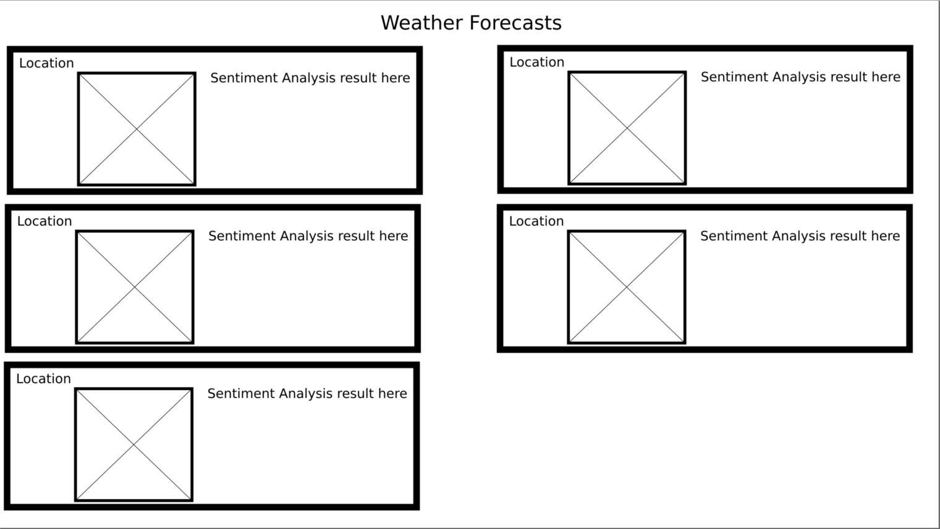I plan to make it so that the boxes rearrange into a single column if the screen is narrower than my screen. The number of boxes will change depending on how many locations I choose to track. The boxes with the X on them is a placeholder for the graphs that I lack the data for. The specification suggests 5 so I have 5 boxes for now.

# Numerical Sources

I have chosen to source my weather data from the Met Office and have chosen 5 locations spread across the United Kingdom

Camborne (South-West tip of England) - <https://www.metoffice.gov.uk/pub/data/weather/uk/climate/stationdata/cambornedata.txt>

Heathrow (Capital) - <https://www.metoffice.gov.uk/pub/data/weather/uk/climate/stationdata/heathrowdata.txt>

Durham (North England) - <https://www.metoffice.gov.uk/pub/data/weather/uk/climate/stationdata/durhamdata.txt>

Braemar (Central Scotland) - <https://www.metoffice.gov.uk/pub/data/weather/uk/climate/stationdata/braemardata.txt>

Armagh (Southern Northern Ireland) - <https://www.metoffice.gov.uk/pub/data/weather/uk/climate/stationdata/armaghdata.txt>

# Text Sources

I intend to source data for sentiment analysis from Twitter search. Due to the fact that people’s opinion of the weather has no impact on the weather (save for the fact that one person’s ‘light drizzle’ may be another’s ‘torrential rain’), I am uncertain if I should be sourcing peoples’ tweets on weather for the locations I am tracking or the tweets of a Twitter Weather bot and analysing if it sounds positive or negative. Test searches for weather + place name are decidedly not very weather-related. Furthermore, the locations that I have data for people are unlikely to mention in tweets. If I do a test search and no results are returned I might move the location for sentiment analysis to the nearest large city and try again as weather stations and cities are usually mutually exclusive. I could also use searches by region to obtain enough data.

* Camborne - [https://twitter.com/search?q=weather%20Camborne&src=typed\_query](https://twitter.com/search?q=weather Camborne&src=typed_query)
* Heathrow – [https://twitter.com/search?q=weather%20Heathrow&src=typed\_query](https://twitter.com/search?q=weather Heathrow&src=typed_query) (This search does not return much current data so I might swap it for London for the text source
* Durham – [https://twitter.com/search?q=weather%20Durham&src=typed\_query](https://twitter.com/search?q=weather Durham&src=typed_query)
* Braemar - [https://twitter.com/search?q=weather%20Braemar&src=typed\_query](https://twitter.com/search?q=weather Braemar&src=typed_query) (Nearest cities are either Perth or Aberdeen if not enough data is returned)
* Armagh – [https://twitter.com/search?q=weather%20Armagh&src=typed\_query](https://twitter.com/search?q=weather Braemar&src=typed_query) (40 miles from Belfast, other close settlements aren’t much larger than itself)

# Static Website



Browser address bar says the URL is <https://cst3130-benmanuel-staticpage.s3.us-east-1.amazonaws.com/index.html>